Bangladesh Medical Association (BMA)
List of Life Member-9
63. BMA Sreemangal Branch

Sl No | Voter No | Voter Details
1 | Voter No  LM-6300001 | DR. HARI PADA ROY  F/Name: Late. Harendra Lal Roy  M/Name: Mrs. Provashini Roy  BM & DC Reg. No: 11144  NID:  Cell: 01711119823  Address: UH&FPO Sreemangal, Upazilla: Sreemongal, Dist: Moulvibazar.  Blood Group: O+
2 | Voter No  LM-6300002 | DR. FARZANA CHOWDHURY  F/Name: Feroze Bakht Chowdhury  M/Name: Rabeya Khanom Chowdhury  BM & DC Reg. No: 31068  NID: 2695051193637  Cell: 01712813904  Address: Upaziila Health Complex , Sreemongal, MoulviBazar.  Blood Group: A+
3 | Voter No  LM-6300003  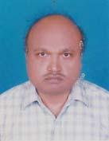 | DR. NIBASH CHANDRA PAUL  F/Name: Late. Surendra Chandra Paul  M/Name: Late. Taranga Bala Paul  BM & DC Reg. No: 26871  NID: 5828304045930  Cell: 01711325713  Address: Purbasha R/A, Srimongal, Moulvibazar.  Blood Group: AB+
4 | Voter No  LM-6300004  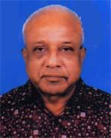 | DR. SADHAN CHANDRA GHOSH  F/Name: Late Lal Mohon Ghosh  M/Name: Late. Biroja Sundori Ghosh  BM & DC Reg. No: 2305  NID: 5818385016588  Cell: 01711148493  Address: Lal Das R/A, Hazi Road, Sreemangal,  Blood Group: B+
5 | Voter No  LM-6300005 | DR. MD. HABIBUR RAHMAN  F/Name: Hazi Md. Jalal Uddin Sarker  M/Name: Mrs. Farida Begum  BM & DC Reg. No: 15082  NID: 5828301040469  Cell: 01711983505  Address: Jalalia Road, Sreemongol. Moulavibazar  Blood Group: AB+
6 | Voter No  LM-6300006 | DR. PRODIP LAL BANIK  F/Name: Late Surendra Mohon Banik  M/Name: Renu Bala Banik  BM & DC Reg. No: 11480  NID: 5818385104983  Cell: 01711332541  Address: Banik Nilay, 14/1, Suravires/Area, South Bharaura, Sreemangal, Mouluvibazar  Blood Group: O+
7 | Voter No  LM-6300007 | DR. MD. SHAZZAD HOSSAIN CHOWDHURY  F/Name: Late. Nurul Alam Chowdhury  M/Name: Mrs. Shamsun Nahar Begum  BM & DC Reg. No: 38359  NID: 2693622420017  Cell: 01936418752  Address: Upazila Health Complex, Sreermangal, Moulovibazar  Blood Group: B+
8 | Voter No  LM-6300008 | DR. MOHAMMAD MOHSIN  F/Name: Jafar Ahmed  M/Name: Mariam Shamsun Nahar  BM & DC Reg. No: 35007  NID: 2699040723668  Cell: 01716517725  Address: Sreemangal Upozila Health Complex, Moulovibazar  Blood Group: A+
9 | Voter No  LM-6300009  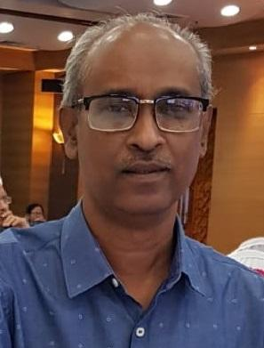 | DR. SATYAKAM CHAKRABORTY  F/Name: Late Mohendra Kumar Chakraborty  M/Name: Late Nilima Chakraborty  BM & DC Reg. No: 14184  NID: 8692078416  Cell: 01715039504  Address: 16, Baridara R/A,Moulovibazar sadar, Post Sreemangal, Distlrict: Moulovibazar  Blood Group: A-

